Experiment-4
Program:
import cv2
# Read image
img = cv2.imread("image.jpg")
# Convert to grayscale
gray = cv2.cvtColor(img, cv2.COLOR_BGR2GRAY)
# Histogram equalization
equalized = cv2.equalizeHist(gray)
# Display images
cv2.imshow("Original Gray Image", gray)
cv2.imshow("Equalized Image", equalized)
cv2.waitKey(0)
cv2.destroyAllWindows()
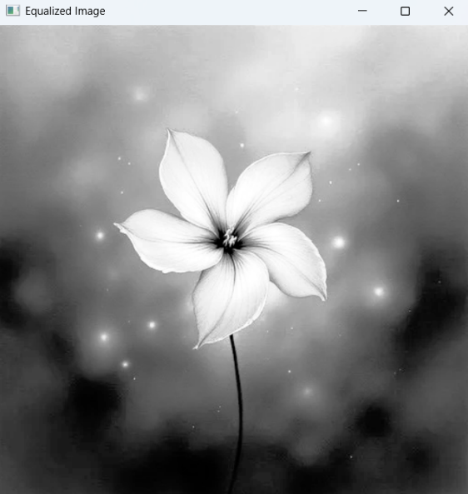
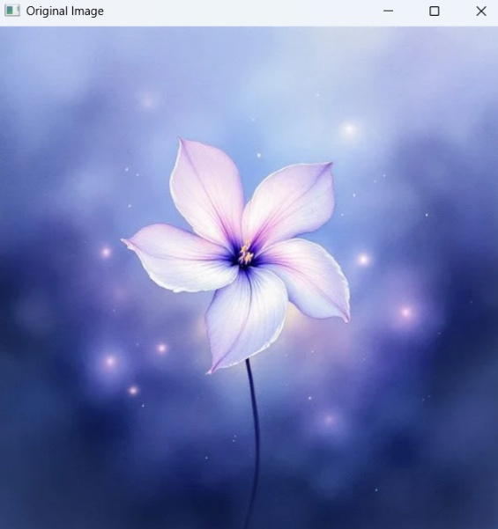
Input: Output:

